THE RELATIONSHIP BETWEEN SURFACE WATER QUALITY AND MANGROVE DENSITY ON PASARAN ISLAND, EAST TELUKBETUNG DISTRICT, BANDAR LAMPUNG CITY

Jundy Zaky Makarim^{1*}, Slamet Budi Yuwono^{1, 2, 4, 5}, Indra Gumay Febryano^{1, 3, 4}, Arief Darmawan^{1, 2, 4}, Irwan Sukri Banuwa^{1,2,4,5}

¹Forestry Study Program, Faculty of Agriculture, Universitas Lampung
²Master of Forestry Study Program, Faculty of Agriculture, Universitas Lampung
³Coastal and Marine Area Management Study Program, Universitas Lampung
⁴Master of Environmental Science Study Program, Universitas Lampung
⁵Doctoral Program in Agricultural Sciences, Universitas Lampung
Jl. Prof. Dr. Soemantri Brojonegoro No 1, Bandar Lampung 35145 Indonesia
Email: jundyzm123@gmail.com

ABSTRACT

The decline in mangrove land cover is a serious concern, because it can increase the possibility of sea water intrusion in coastal areas. This research aims to assess the relationship between surface water quality and mangrove density on Pasaran Island. The data obtained were analyzed using the multiple linear regression method to evaluate the simultaneous influence of mangrove density and sampling zone on various water quality parameters, including salinity, dissolved oxygen, electrical conductivity, total dissolved solids, and pH. The research results show that the denser the mangrove density, the lower the salinity level, but the density does not affect other water quality parameters, such as: dissolved oxygen, electrical conductivity, total dissolved solids, pH. The sampling zone also influences several water quality parameters, where zones closer to the coastline show higher parameter values ​​than transition zones or those further from the coast. External factors such as sea water intrusion and domestic waste pollution play a greater role in influencing water quality. The government should make efforts to conserve and rehabilitate forests and mangrove lands, especially in urban areas.

Keywords : intrusion, water quality, mangroves, coast, density

Introduction
The mangrove ecosystem is a collection of distinctive plants, animals, and microorganisms that have adapted to the unstable and fluctuating environment of tropical coastal zones (Saha et al., 2022). Mangrove ecosystems play a crucial role in coastal protection and act as carbon sinks (Dash et al., 2024). Mangroves consist of shrubs or small trees that grow in sheltered tropical and subtropical coastal areas around the world, thriving in anoxic surface sediment conditions (Wang, 2013; Wang, 2019; Wang & Gu, 2021). Besides functioning as pollutant filters and feeding grounds for various species, coastal communities utilize mangrove fruits for food, collect dead branches for firewood (Febryano et al., 2014), and believe in their herbal medicinal properties as part of local wisdom (Duryat et al., 2024).
Globally, mangrove forests have experienced degradation and fragmentation over the past few decades due to anthropogenic threats such as deforestation for land conversion, overexploitation of resources, and pollution (Friess et al., 2019; Ahmed et al., 2022). While mangroves serve as vital natural phytoremediation systems, their ecosystems are highly sensitive to all forms of disturbance (Nguyen et al., 2020). Such disturbances can significantly impact coastal sustainability, particularly in relation to clean water availability. A study by Tiara et al. (2017) demonstrated that mangrove density and distance from the coastline influence water quality.
A healthy mangrove ecosystem supports community livelihoods by preventing abrasion and saltwater intrusion and by trapping pollutants (Turisno et al., 2021). The decline in mangrove cover is a critical concern, as it increases the risk of seawater intrusion into coastal areas. Therefore, this study aims to assess the relationship between surface water quality and mangrove density.

RESEARCH METHODS
This research was conducted in coastal areas adjacent to three districts: Telukbetung Timur, Telukbetung Selatan, and Bumi Waras, during August 2024. The tools used included a laptop, GPS (Global Positioning System), DSLR
camera, measuring tape, meter tape, tally sheet, water quality tester, dissolved oxygen meter, hand refractometer, sample bottles, tissues, and stationery. The materials used were surface water samples collected from the research sites and standard calibration solutions as required.
The study area was divided into three stations based on mangrove density. Each station comprised several observation plots, with the number of plots adjusted according to the area and characteristics of each station. The locations were categorized into:
1.Coastal Zone: The area closest to the shoreline, where water is most affected by seawater intrusion.
2. Middle Zone: Located within the central mangrove vegetation, where marine and terrestrial influences are more balanced.
3.Transition Zone: The area closest to land or residential settlements, where surface water is influenced by groundwater and human activities.
The method used to measure mangrove vegetation density was the vegetation analysis method using plots measuring 10 × 10 meters. These plots were systematically placed in three stations categorized based on the level of mangrove density: high, medium, and low. In each plot, the number of individual mangrove trees was counted, and the results were used to determine the vegetation density at each station.
The collected data were analyzed using multiple linear regression analysis to evaluate the simultaneous influence of mangrove density and sampling zone on various water quality parameters. The water quality parameters analysed included salinity, Dissolved oxygen (DO), Electrical Conductivity (DHL), Total Dissolved Solids (TDS), and pH. The mangrove density variable was measured in units of trees per hectare, while the sampling zone variable was categorised into transition zone, middle zone, and coastal zone, each of which was numerically coded. The water quality parameters analysedsalinity, dissolved oxygen (DO), electrical conductivity (EC), total dissolved solids (TDS), and pH—served as dependent variables. A multiple linear regression model was used to examine the relationship between mangrove density, sampling zone, and the water quality parameters, formulated as follows:

Y = β₀ + β₁ X₁ + β₂ X₂ + ϵ

Where : Y₁ = Water Quality; β₀ = Intercept;
β₁ = Regression coefficient for mangrove density; β₂ = Regression coefficient for sampling zone; X₁ = Mangrove density; X₂ = Sampling zone; ϵ = Error term in the model

In this multiple regression analysis, the hypotheses tested for each water quality parameter were:
- H₀ = There is no significant effect of mangrove density and sampling zone on the water quality parameters (salinity, DO, EC, TDS, pH).
- H₁ = At least one of the variables, mangrove density or sampling zone, has a significant effect on the water quality parameters.

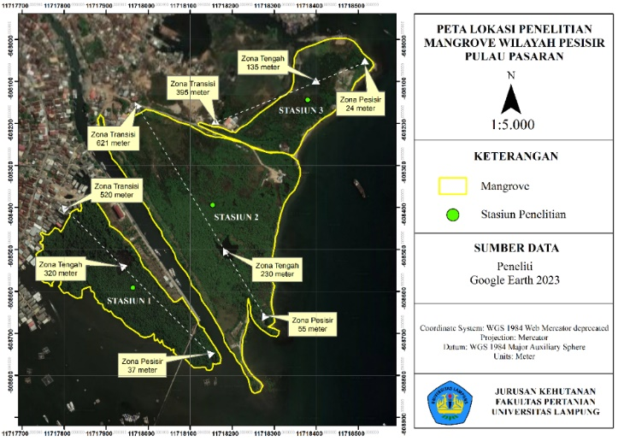

Figure 1. Research Location

RESULT AND DISCUSSION

General Condition of the Research Site
The remaining mangrove community in Kelurahan Kota Karang is located along the coastal area of Kota Karang, adjacent to the pedestrian bridge leading to Pasaran Island (Kurnia & Hasana, 2016). The mangrove forest area in the Kota Karang coast has increased annually despite the mangrove community facing significant pollution pressure. According to Maharani et al. (2021), the mangrove area increased from 2017 to 2019 (Figure 2) due to planting efforts by various Non-Governmental Organizations (NGOs) and related agencies committed to the preservation of the Kota Karang Bandar Lampung mangrove ecosystem.
The mangrove species growing in this area include Avicennia alba, Avicennia marina, Bruguiera cylindrica, Lumnitzera racemosa, Rhizophora apiculata, and Sonneratia alba. Among these, Avicennia alba or api-api is the most dominant species. The condition of the mangrove community is concerning due to the accumulation of waste settled in the mud or substrate where the mangroves grow, compounded by the presence of many fishing boats. Numerous settlements have been established on muddy land, which is the natural habitat of mangroves. The local community has yet to fully realize the importance of mangrove conservation due to limited information and ecological awareness regarding mangrove forests (Permata et al., 2021).
The marine waters around Pasaran Island are polluted mainly by plastic waste. This pollution theoretically has the potential to disrupt the aquatic ecosystem if it persists over a certain period. The pollution level in the waters around Pasaran Island has been classified as heavily to severely polluted (Hamid et al., 2023). The waste accumulation on Pasaran Island results from reclamation activities by residents for residential purposes, making it susceptible to incoming debris during high tides (Noor et al., 2021)

Relationship Between Water Quality and Mangrove Density
The condition of the mangrove ecosystem on Pasaran Island varies across the three observed research stations. Station 1, with a mangrove density of 1,385.71 trees/ha dominated by Avicennia alba, falls into the moderate density category. Station 2 has a density of 966.66 trees/ha dominated by Avicennia marina, categorized as low density. Station 3 has an even lower density of 733.33 trees/ha dominated by Lumnitzera racemosa, indicating slower mangrove growth.
Understanding the relationship between water quality and mangrove density is crucial for comprehending the role of the mangrove ecosystem in maintaining coastal environmental stability. Each increase of 1 tree/ha in mangrove density reduces salinity by 0.0178 ppt, indicating that higher mangrove density effectively reduces seawater intrusion and lowers salinity in the surrounding area (Figure 3). This finding aligns with the characteristic role of mangroves as buffer ecosystems that play a critical role in mitigating seawater intrusion (Umadji et al., 2023). In this context, mangroves function as natural filters that help maintain water quality by reducing salt content.

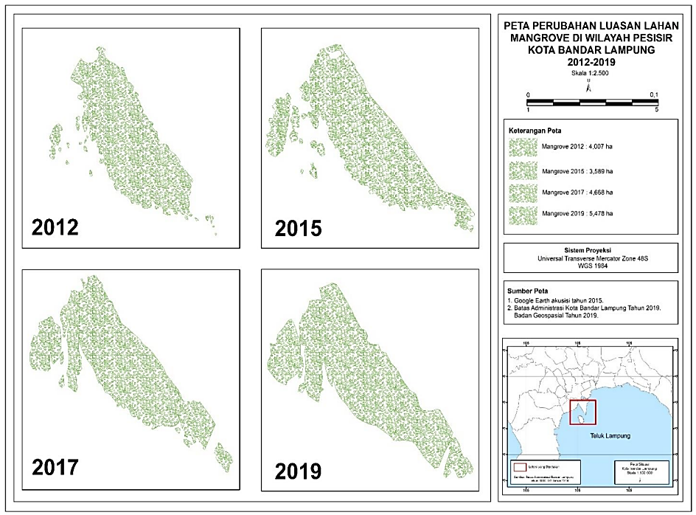
Source: Maharani et al. (2021)

Figure 2. Mangrove Area from 2012 to 2019

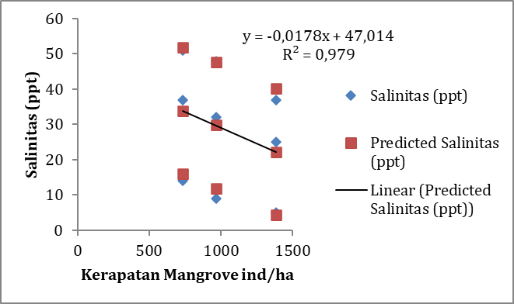
Mangrove Density ind/ha
Salinity (ppt)
Salinity ppt

Figure 3. Relation Between Mangrove Density and Salinity

The closer an area is to the sea, the higher its salinity, due to greater exposure to seawater intrusion (Figure 4), considering that coastal zones are directly exposed to seawater which naturally has a high salt content. Zones farther from the sea, such as inner mangrove forest areas or near settlements, tend to have lower salinity because the direct influence of seawater is reduced (Kuminah & Aadziima, 2018).
Both mangrove density and sampling zone significantly affect salinity (Figures 3 and 4). An R-squared value of 0.979 indicates that 97.9% of the variation in salinity can be explained by density and zone. The significance value or p-value for density is 0.002 and for zone is <0.001, both less than 0.05, thus the Null Hypothesis (H₀), which states that density and zone have no effect on salinity, is rejected. The Alternative Hypothesis (H₁), which states that these two variables have a significant effect, is accepted. This finding aligns with Budhiawan et al. (2022), who stated that mangrove vegetation acts as a natural barrier reducing the rate of seawater intrusion.
Mangrove density positively influences dissolved oxygen (DO) levels (Figure 5). The denser the mangrove vegetation, the higher the dissolved oxygen content in the water. This can be explained by several mechanisms. First, mangroves perform photosynthesis which produces oxygen. Second, mangrove roots slow water flow, so calmer water tends to absorb more oxygen from the atmosphere. Additionally, mangroves create more balanced aquatic conditions that support aquatic biota contributing to increased dissolved oxygen levels (Pinontoan et al., 2023).
The zone plays an important role in determining dissolved oxygen levels (Figure 6). Zones closer to the sea tend to have lower DO levels because seawater has a lower capacity to absorb and retain oxygen. Conversely, zones farther from the sea, especially areas with high mangrove density, tend to have higher dissolved oxygen levels. This is because freshwater or brackish water can retain dissolved oxygen better than saline water (Patty & Huwae, 2023).

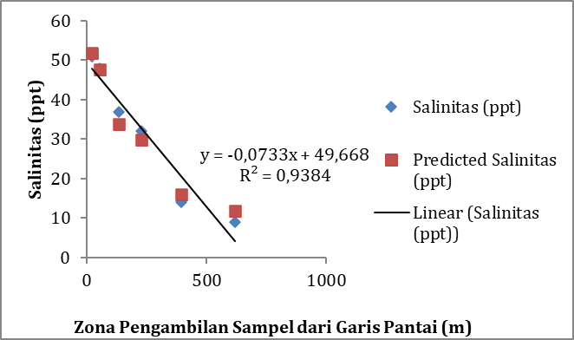
Sampling zone from the shoreline (m)
Salinity (ppt)
Salinity ppt

Figure 4. Relationsip between sampling zone and salinity
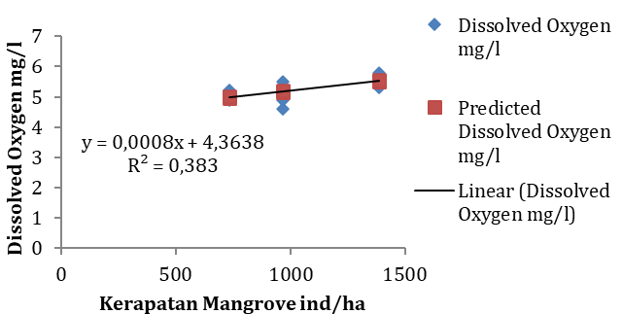
Mangrove Density ind/ha

Figure 5. Relationship between mangrove density and dissolved oxygen

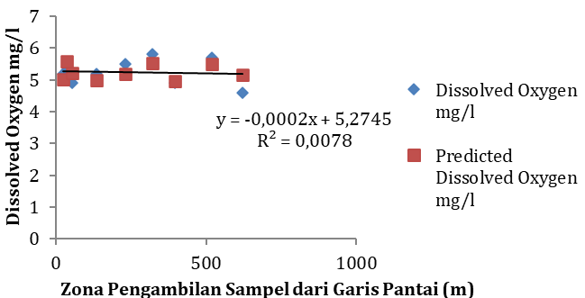
Sampling zone from the shoreline (m)

Figure 6. Relationship between Sampling Zone and Dissolved Oxygen

Mangrove density and sampling zone do not have a significant effect on dissolved oxygen (Figures 5 and 6). The significance values for density and zone are 0.104 and 0.827, respectively, both greater than 0.05, thus the Null Hypothesis (H₀) is accepted, meaning that mangrove density and zone do not significantly influence dissolved oxygen levels.
The R-squared value of 0.383 indicates that only 38.3% of the variation in DO can be explained by this model, suggesting that other factors such as water temperature, biological activity, and water currents may have a greater influence on dissolved oxygen levels. Regression results confirm that mangrove density and zone do not significantly affect DO. According to Sumangando et al. (2022), dissolved oxygen is more influenced by biological activity and aquatic conditions, such as temperature and currents.
Mangrove density also has a negative correlation with Electrical Conductivity (EC) (Figure 7). The denser the mangrove vegetation, the lower the electrical conductivity in the water. Mangroves function as filters that trap nutrients and pollutants, leading to a reduction in dissolved ion concentrations that increase electrical conductivity (Marolop & Herawati, 2020). This explains why locations with high mangrove density tend to have slightly lower EC values.
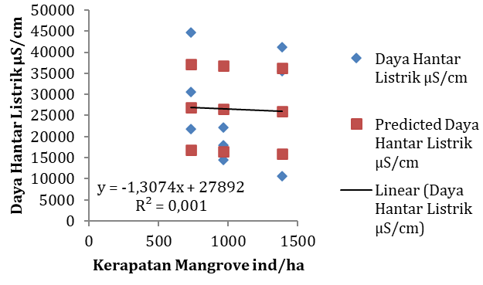
Electrical conductivity µS/cm
Mangrove Density ind/ha

Figure 7. Relationship between Mangrove Density and Electrical Conductivity

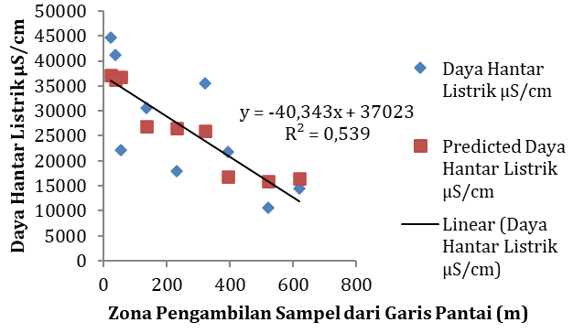
Electrical conductivity µS/cm
Sampling zone from the shoreline (m)

Figure 8. Relationship between Sampling Zone and Electrical Conductivity

EC values tend to increase in zones closer to the sea because seawater contains higher concentrations of ions that can increase electrical conductivity (Figure 8). Conversely, zones farther from the sea tend to have lower EC values due to lower ion content (Lestari et al., 2021). Therefore, different sampling zones may exhibit variations in EC values, with coastal zones showing the highest values, and zones farther from the sea or protected by mangrove forests showing lower values.
Sampling zone has a significant effect on EC with a significance value of 0.038, while mangrove density is not significant with a value of 0.914 (Figures 7 and 8). Therefore, the Null Hypothesis (H₀) is rejected for zone but accepted for density. This indicates that changes in zone significantly affect electrical conductivity, whereas mangrove density does not have a meaningful impact.
Higher electrical conductivity in coastal zones can be explained by the elevated ion concentration due to seawater intrusion. An R-squared value of 0.539 indicates that 53.9% of the variation in EC can be explained by this model. Regression results show that sampling zone significantly affects EC, while mangrove density does not. In coastal areas, seawater intrusion increases the concentration of dissolved ions in groundwater, as seawater entering the aquifer contains higher amounts of salts and dissolved minerals compared to freshwater (Terinathe et al., 2023).
Mangrove density has a positive effect on Total Dissolved Solids (TDS), meaning that with increasing mangrove density, TDS also increases (Figure 9). In this case, mangroves do not contribute to a reduction in TDS, possibly due to other factors such as erosion and variations in pollution at different stations, even when some stations have higher mangrove density. TDS reduction may be more influenced by other environmental factors such as human activities, erosion, and sedimentation resulting from mangrove forest damage, which affect TDS levels in the water (Argiantini et al., 2021).
The influence of zonation on TDS indicates a tendency for areas closer to the sea to have higher TDS levels (Figure 10). Conversely, zones located farther inland—especially those protected by mangrove vegetation—tend to exhibit lower TDS levels due to the reduced influence of seawater intrusion. Generally, TDS concentrations increase as the distance to the shoreline decreases. However, the distribution pattern of TDS may also be affected by other factors such as local geological conditions and human activities (Snalles et al., 2023).

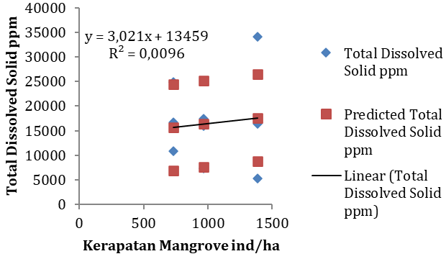
Mangrove Density ind/ha

Figure 9. Hubungan antara Kerapatan Mangrove dengan Total Dissolved Solid

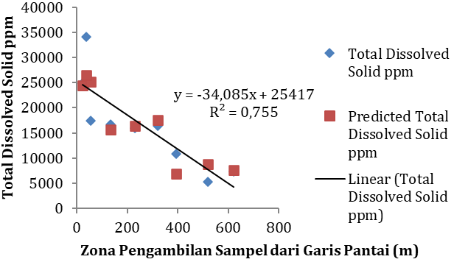
Sampling zone from the shoreline (m)

Figure 10. Relationship between Mangrove Density and Total Dissolved Solids (TDS)
The sampling zone has a highly significant effect with a significance level of 0.005, while mangrove density does not have a significant effect, with a significance level of 0.645 (Figure 9 and Figure 10). Based on this, H1 is accepted for the zone and H₀ is accepted for mangrove density, indicating that the sampling zone affects the total dissolved solids (TDS) in the water, while mangrove density does not have a significant effect.
The R-squared value of 0.755 indicates that 75.5% of the variation in TDS can be explained by this model. The coastal zone has a much higher TDS compared to the transition and central zones, suggesting that this area is more affected by seawater intrusion, which brings more dissolved substances into the water. The regression results show that the sampling zone has a significant effect on TDS, while mangrove density is not significant. The increase in dissolved solids in the water is also caused by the presence of organic materials in the form of ions, such as: calcium, phosphate, nitrate, sodium, potassium, magnesium, bicarbonate, carbonate, and chloride (Manune et al., 2019).
The effect of mangrove density on pH tends to be weaker compared to its effect on other parameters such as salinity (Figure 11). Regression analysis shows that an increase in mangrove density does not significantly affect changes in pH. This may be because pH is more influenced by biological factors such as microbial activity and organic matter in the water than by mangrove density itself (Darwati et al., 2022). Nevertheless, mangroves still play a role in stabilizing pH by absorbing organic matter and pollutants that can affect the water’s acid-base balance.
The sampling location zones tend to be more stable in terms of pH compared to mangrove density (Figure 12). Seasonal fluctuations, such as rainfall and biological activity in the water, can influence CO₂ levels and thus affect pH. However, despite these variations, pH values tend to remain relatively stable over longer periods (Alimby & Triajie, 2021).
Neither mangrove density nor the sampling zone had a significant effect on water pH, with significance values of 0.346 for mangrove density and 0.480 for the sampling zone (Figures 11 and 12). Since both significance values are greater than 0.05, the Null Hypothesis (H₀) is accepted, indicating that neither mangrove density nor the sampling zone has a significant effect on water pH.
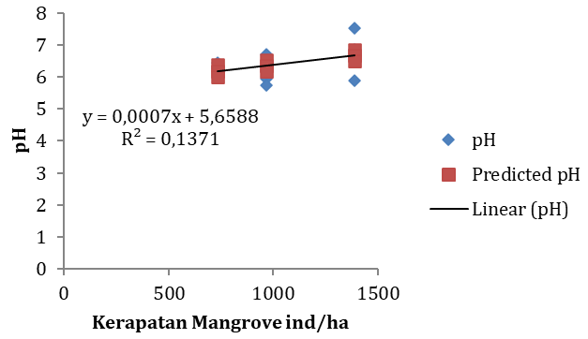
Mangrove Density ind/ha

Figure 11. The Relationship Between Mangrove Density and pH

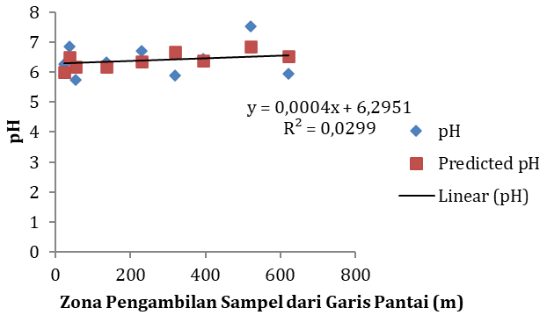
Sampling zone from the shoreline (m)

Figure 12. Relationship Between Sampling Zone and pH

The R-squared value of 0.212 indicates that only 21.2% of the variation in pH can be explained by this model. Regression results show that mangrove density and zone do not have significant effects. pH in coastal waters tends to fluctuate greatly depending on the input of freshwater from land and seawater. Open waters generally have higher pH values compared to more enclosed waters (Radja et al., 2023).
The sampling zone has a significant effect on several water quality parameters, especially salinity, electrical conductivity (EC), and total dissolved solids (TDS). Coastal zones closer to the sea tend to have water quality more affected by seawater intrusion, resulting in increased salinity, EC, and TDS in these areas. Mangrove density only had a significant effect on salinity, indicating that higher density can help resist seawater intrusion and lower salinity, but is not significant in affecting other parameters such as dissolved oxygen (DO), EC, TDS, or pH.
Persistent pollution can reduce the capacity of mangroves to function effectively in filtering surface water (Matitaputy et al., 2024). Groundwater pollution refers to changes in groundwater composition caused by human activity or natural processes, leading to a decline in groundwater quality to levels that are no longer suitable for its intended use (Khoiriyah & Widiyanti, 2023). Thus, the sampling zone plays a more dominant role in influencing variations in water quality at the study sites, while mangrove density only significantly contributes to reducing salinity. This is due to the high level of pollution from waste and dissolved contaminants at various research stations, limiting the mangroves' ability to effectively filter the water.

CONCLUSION
The higher the mangrove density, the lower the salinity levels at the study sites. Mangrove density does not significantly affect other water quality parameters such as electrical conductivity, total dissolved solids, pH, or dissolved oxygen. In contrast, the sampling zone does influence several water quality parameters. Zones closer to the coast show higher values for each parameter compared to transition zones or zones farther inland. External factors such as seawater intrusion and domestic waste pollution are more dominant in affecting water quality. The government needs to take action in restoring mangrove areas, especially in urban regions.

REFERENCES

Ahmed S, Sarker SK, Friess DA, Kamruzzaman M, Jacobs M, Islam MA, Alam MA, Suvo MJ, Sani MNH, Dey T, Naabeh CSS, Pretzsch H. 2022. Salinity reduces site quality and mangrove forest functions. From monitoring to understanding. Science of the Total Environment, 853: 158662. doi: 10.1016/j.scitotenv.2022. 15 8662
Alimby WVA, Triajie H. 2021. Tingkat keasaman pesisir perairan Kamal Kabupaten Bangkalan Madura pada musim peralihan. Juvenil: Jurnal Ilmiah Kelautan dan Perikanan. 2(3):186-201. doi: 10.21107/juvenil.v2i3.11767.
Argiantini NPW, Perwira IY, Ernawati NM. 2021. Perbandingan jumlah bakteri pada sedimen mangrove di ekosistem mangrove rehabilitasi dan alami di Desa Perancak, Jembrana, Bali. Current Trends in Aquatic Science. 4(1):63-68.
Budhiawan A, Susanti A, Hazizah S. 2022. Analisis dampak pencemaran lingkungan terhadap faktor sosial dan ekonomi pada wilayah pesisir di Desa Bagan Kuala Kecamatan Tanjung Beringin Kabupaten Serdang Bedagai. Jurnal Pendidikan Tambusai, 6(1):240-249. doi: 10.3100 4/jptam.v6i1.2859.
Darwati H, Poedjirahajoe E, Sadono R, Soewarno HB. 2022. Karakteristik perairan dan species mangrove dominan di Pulau Panjang Desa Padang Tikar II, Kabupaten Kubu Raya Kalimantan Barat. Jurnal Hutan Lestari. 10(4):1002-1009. doi:10.26418/jhl.v10i4.61230.
Dash RK, Kumar K, Shukla SP, Kumar S, Karmakar S, Paul T. 2024. Effect of triclosan on phosphate solubilising bacteria in mangrove ecosystem: in-vitro and in-vivo. Journal of Hazardous Materials Letters. 100136. doi: 10.1016/ j.hazl.2024.100136.
Duryat, Yuwono SB, Riniarti M, Hidayat KF, Hidayat W, Rodiani, Damai AA, Prasetyo P, Dani HA. 2024. Species diversity and herbal medicine utilization of mangrove plants: a comparative study among coastal communities in Lampung. Jurnal Sylva Lestari. 12(3):781-800. doi: 10.23 960/jsl.v12i3.936.
Elwin A, Robinson EJ, Feola G, Jintana V, Clark J. 2024. How is mangrove ecosystem health defined? A local community perspective from coastal Thailand. Ocean & Coastal Management. 251:107037. doi: 10.1016/j.ocecoaman. 2024.107037.
Febryano IG, Suharjito D, Darusman D, Kusmana C, Hidayat A. 2014. The roles and sustainability of local institutions of mangrove management in Pahawang Island. Jurnal Manajemen Hutan Tropika. 20(2):69-76. doi: 10.7226/jtf m.20.2.69.
Friess DA, Rogers K, Lovelock CE, Krauss KW, Hamilton SE, Lee SY, Lucas R, Primavera J, Rajkaran A, Shi S. 2019. The state of the world's mangrove forests: past, present, and future. Annual Review of Environment and Resources. 44(1):89-115. doi: 10.1146/annurev-environ-10 1718-033302.
Hamid A, Riani E, Warlina L. 2023. Analisis pencemaran logam berat pada sedimen permukaan di dasar perairan laut Pulau Pasaran. Reksabumi. 2(1):65-74. doi: 10.33830/Reksabumi.v2i1.4840.2023
Khoiriyah L, Widiyanti A. 2023. Efektifitas tanaman mangrove Rhizopora mucronata dan bakteri dalam menurunkan kadar salinitas air payau. Nusantara Technology and Engineering Review. 1(1):1-9. doi: 10.55732/nter. v1i1.1068.
Kurnia AA, Hasana A. 2016. Analisis spasial dan temporal perubahan karakteristik ekosistem mangrove di wilayah Pesisir Kota Bandar Lampung. Journal of Environment and Sustainable Development. 1(1):1-17.
Kusminah IL, Aadziima AF. 2018. Pengaruh salinitas air laut terhadap nilai potensial proteksi anoda dengan metode ICCP. Jurnal Universitas 17 Agustus 1945 Surabaya. 252-253.
Lestari IL, Singkam AR, Agustin F, Miftahussalimah PL, Maharani AY, Lingga, R. 2021. Perbandingan kualitas air sumur galian dan bor berdasarkan parameter kimia dan parameter fisika. Bioedusains: Jurnal Pendidikan Biologi Dan Sains. 4(2):155-165. doi: 10.31539/bioedu sains.v4i2.2346.
Maharani, MK, Febryano IG, Tresiana, N, Banuwa, IS. 2021. Perubahan luasan lahan mangrove sebagai ruang terbuka hijau di wilayah pesisir Kota Bandar Lampung. Journal of Tropical Marine Science. 4(1):18-24. doi: 10.33019/jour. trop.mar.sci.v4i1.2038.
Mamonto, AAN, Sari, L, Mamonto, S, Usulu, EM, Tuhumurry, HA. 2023. Kegiatan pengabdian masyarakat penaman mangrove di Ciberi. Jurnal Pengabdian Kolaborasi Dan Inovasi IPTEKS. 1(5):582-587. doi: 10.59407/jpki2.v1 i5.116.
Marolop GS, Herawati P. 2020. Analisis kualitas air permukaan Rawa Gambut Rasau bervegetasi mangrove di desa Rantau Panjang Kabupaten Muaro Jambi. Jurnal Civronlit Unbari. 5(2):59-62. doi: 10.33087/civronlit.v5i2.70.
Matitaputy E, Retraubun ASW, Selanno, DA, Papilaya, RL, Puturuhu, F. 2024. Dampak pemanfaatan ruang terhadap kelestarian mangrove di Teluk Ambon, Indonesia. Agro Bali: Agricultural Journal. 7(2):514-528. doi: 10.37637/ ab.v7i2.1482.
Nguyen, A, Le, BV, Richter, O. 2020. The role of mangroves in the retention of heavy metal (Chromium): a simulation study in the Thi Vai River Catchment, Vietnam. International Journal Of Environmental Research And Public Health. 17(16):5823. doi: 10.3390/ijerph17165 823.
Noor, NM, Utomo, DSC, Hastuti, AY, Habibi, A, Ali, M. 2021. Pengembangan potensi wisata bahari berbasis masyarakat di Pulau Pasaran, Bandar Lampung. Inovasi Pembangunan Jurnal Kelitbangan. 9(1): 103-114. doi: 10.35450/jip.v9i01.219
Patty, SI, Huwae, R. 2023. Temperature, salinity and dissolved oxygen west and east seasons in the waters of Amurang Bay, North Sulawesi. Jurnal Ilmiah Platax. 11(1):196-205. doi: 10.35800/ jip.v11i1. 46651.
Permata, CO, Iswandaru, D, Hilmanto, R, Febryano, IG. 2021. Persepsi masyarakat pesisir Kota Bandar Lampung terhadap hutan mangrove. Journal of Tropical Marine Science. 4(1):40-48. doi: 10.33019/jour.trop. mar.sci.v4i1.2078.
Pinontoan, MP, Paulus, JJ, Wullur, S, Rompas, RM, Ginting, EL, Pelle, WE. 2023. Oksigen terlarut dan pH di air sisipan sedimen mangrove dan pesisir di Desa Bulutui Kecamatan Likupang Barat. Jurnal Pesisir dan Laut Tropis. 11(1):132-138. doi: 10.35800/jplt.11.1. 2023.52733.
Radja, CH, Toruan, LNL, Kangkan, AL. 2023. Variabel kondisi lingkungan pada ekosistem mangrove di Kota Kupang. Jurnal Vokasi Ilmu-Ilmu Perikanan. 4(1): 19-28. doi: 10.35726/jvip.v4i1.1740.
Saha, A, Sarkar, C. 2022. Protecting the precious sundarbans: a comprehensive review of biodiversity, threats and conservation strategies in the mangrove ecosystem. Conscientia. P.60.
Snalles, ET, Fitrada, W, Lisha, SY. 2023. Analisis intrusi air laut dengan pengukuran total dissolved solids (TDS), daya hantar listrik (DHL) dan salinitas air sumur gali. Lingkar: Journal of Environmental Engineering. 4(1):57-66. doi: 10.22373/ljee.v4i1.2727.
Sumangando, A, Kawung, NJ, Rompas, RM, Untu, SD, Potalangi, NO. 2022. Analisis kebutuhan oksigen biologi, oksigen terlarut, total suspensi solit dan derajat keasaman pada air Limbah Rumah Sakit Pancaran Kasih Manado. Majalah Info Sains. 3(1):45-50. doi: 10.55724/jis.v3 i1.49.
Terinathe, F, Kololu, M, Limehuwey, R, Hutagalung, R, Puradimaja, DJ. 2023. Fenomena intrusi air laut di Daerah Pesisir Hunuth, Kecamatan Teluk Ambon, Kota Ambon, Maluku. Journal of Science Technology and Visual Culture. 3(3): 335-345.
Tiara, AR, Banuwa, IS, Qurniati, R, Yuwono, SB. 2017. Pengaruh kerapatan mangrove terhadap kualitas air sumur di Desa Sidodadi Kabupaten Pesawaran. Jurnal Hutan Tropis. 5(2):93-98. doi: 10.20527/ jht.v5i2.4362.
Turisno, BE, Dewi, IGS, Mahmudah, S, Soemarmi, A. 2021. Recovery policy and proper management of mangrove forests to preserve environmental sustainability and ecotourism in bangkalan Indonesia. Journal of Environmental Management & Tourism. 12(8):2188-2193. doi: 10.14 505/jemt.v12.8(56).17.
Umadji, NIR, Dunggio, H, Maulana, D, Abdullah, D. 2023. Identifikasi jenis mangrove pada ekosistem mangrove Desa Maleo, Kecamatan Paguat, Kabupaten Pohuwato. Journal of Environmental Engineering Research. 1(1):5-9.
Wang, YS. 2013. Assessment and Remediation Techniques of Mangrove Ecosystems. Beijing: The Science Publishing Company.
Wang, YS. 2019. Molecular Ecology of Mangroves. Beijing: The Science Publishing Company.
Wang, YS, Gu, JD. 2021. Ecological responses, adaptation and mechanisms of mangrove wetland ecosystem to global climate change and anthropogenic activities. International Biodeterioration & Biodegradation. 162:105248. doi: 10.1016/j.ibiod.2021.105248.

